# Threshold Content Migrations to OPS

## Runonce Steps

* 1. Fork and clone the Git repository to your local machine.
  2. Check out a new branch.
  3. Create the content subfolder for your technology area and move your content from the root of the repository into your subfolder. Create subfolders as necessary but try not to go more than two levels deep.

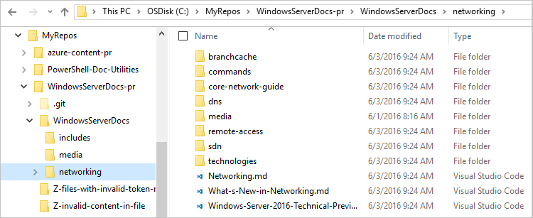

* 1. Run the one-time transformation scripts to complete the following tasks:
     + Migrate your linked media and fix document links to reference the folder structure

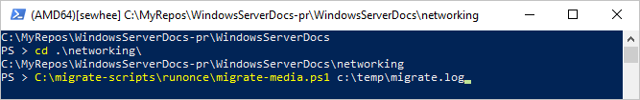

* + - Update the global TOC

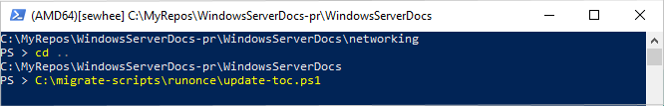

* + - Replace tokens links with actual text

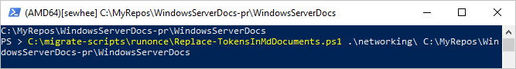

* 1. Commit the changes to your branch, sync your fork and submit a pull request.

At this point the repository should be publishable. However, the filenames do not match the recommended standards. The next set of steps can be performed by the individual content owners to perform bulk rename operations on the content.

## Bulk Rename Steps

1. Check out a new branch.
2. Bulk rename the Markdown files
   1. Run the script to generate the CSV file for renaming Markdown files.

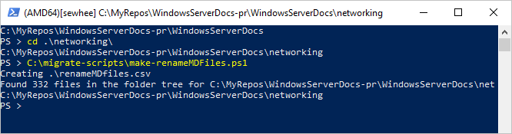

* 1. Edit the CSV file to specify the new filenames you want. Be sure to save the file as CSV. Excel wants to convert it to workbook format.

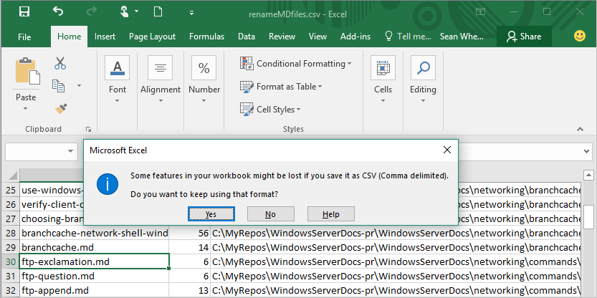

* 1. Run the script to process the Markdown rename CSV file.

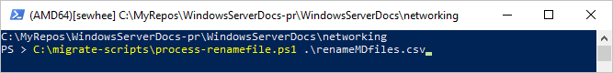

* 1. Repeat steps 2a-2d any time you want to bulk rename Markdown files.

1. Bulk rename the Media files
   1. Run the script to generate the CSV file for renaming Media files.

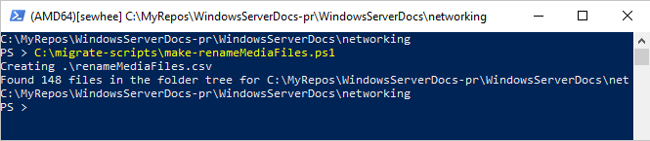

* 1. Edit the CSV file to specify the new filenames you want. Be sure to save the file as CSV. Excel wants to convert it to workbook format.
  2. Run the script to process the Media rename CSV file.

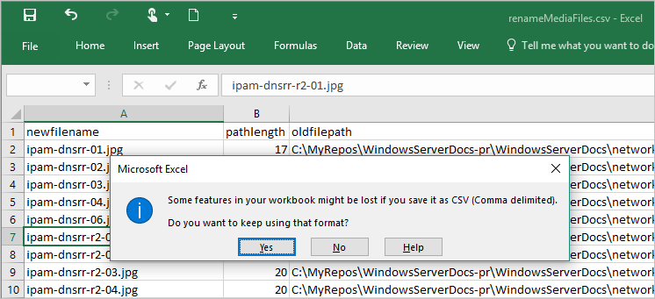

* 1. Repeat steps 3a-3d any time you want to bulk rename Media files.

# Appendix: Script Documentation

NAME

C:\migrate-scripts\runonce\migrate-media.ps1

SYNOPSIS

Migrates all of the linked media and fixes the linked references to match

the new folder structure.

SYNTAX

C:\migrate-scripts\runonce\migrate-media.ps1 [-logfile] <String> [<CommonParameters>]

DESCRIPTION

Run this script from the top most folder of your content hierarchy for your

technology area. The script will scan the folder hierarchy and perform the

following transformations on the content:

- Scan for links to media files and copy the media files from the root media

folder to media subfolder under the current location.

- Fix all links to media files to point to the new media location.

- Fix all links to MD files within the content to point to their new location

in the folder hierarchy.

This assumes that the existing media folder is one-level above the current

folder. This script is intended to be run only once per technology-level folder.

PARAMETERS

-logfile <String>

The full path to a file to log diagnostic output for review. The log

file is used to identify runtime errors and invalid links.

Required? true

Position? 1

Default value

Accept pipeline input? false

Accept wildcard characters? false

<CommonParameters>

This cmdlet supports the common parameters: Verbose, Debug,

ErrorAction, ErrorVariable, WarningAction, WarningVariable,

OutBuffer, PipelineVariable, and OutVariable. For more information, see

about_CommonParameters (http://go.microsoft.com/fwlink/?LinkID=113216).

OUTPUTS

The script creates a log file. You must review the log file for errors and

warning about missing content and invalid links.

-------------------------- EXAMPLE 1 --------------------------

PS > cd "<repo-location>\networking"

PS > <script-repository>\runonce\migrate-media.ps1

NAME

C:\migrate-scripts\runonce\update-toc.ps1

SYNOPSIS

Updates all of the links in the TOC.md file.

SYNTAX

C:\migrate-scripts\runonce\update-toc.ps1 [-targetfolder] <String> [<CommonParameters>]

DESCRIPTION

Run this script from the root folder of the content repository where TOC.md

exists. Point the script at the path for your topic. The script scans all

of the files in the topic folder (recursively) and updates the TOC.md to

point to the new location of the file. This assumes that the file name has

not been changed from what appears in the TOC.md file.

PARAMETERS

-targetfolder <String>

The path to folder tree containing your newly relocated files.

Required? true

Position? 1

Default value

Accept pipeline input? false

Accept wildcard characters? false

<CommonParameters>

This cmdlet supports the common parameters: Verbose, Debug,

ErrorAction, ErrorVariable, WarningAction, WarningVariable,

OutBuffer, PipelineVariable, and OutVariable. For more information, see

about_CommonParameters (http://go.microsoft.com/fwlink/?LinkID=113216).

OUTPUTS

-------------------------- EXAMPLE 1 --------------------------

PS > cd "<repo-location>"

PS > <script-repository>\runonce\update-toc.ps1 .\networking

NAME

C:\migrate-scripts\runonce\Replace-TokensInMdDocuments.ps1

SYNOPSIS

Replaces all 'token' references with with the token value.

SYNTAX

C:\migrate-scripts\runonce\Replace-TokensInMdDocuments.ps1 [-documentsfolder] <String> [-

documentsRoot] <String> [<CommonParameters>]

DESCRIPTION

The command replaces all token references, in all MD documents (recursively),

with the token value.

PARAMETERS

-documentsfolder <String>

The path to the folder (with subfolders) that contains all MD documents

to review and replace for tokens.

Required? true

Position? 1

Default value

Accept pipeline input? false

Accept wildcard characters? false

-documentsRoot <String>

The path to the root folder that contains includes folder that contains

all token MD documents.

Required? true

Position? 2

Default value

Accept pipeline input? false

Accept wildcard characters? false

<CommonParameters>

This cmdlet supports the common parameters: Verbose, Debug,

ErrorAction, ErrorVariable, WarningAction, WarningVariable,

OutBuffer, PipelineVariable, and OutVariable. For more information, see

about_CommonParameters (http://go.microsoft.com/fwlink/?LinkID=113216).

INPUTS

OUTPUTS

A list of token references that are broken; in a list of [TAB] separated

values, in the form of:

<occurrence>'t<document-path>`t<token>`t<broken-reference>

MD files that contain valid token references are updated in place. The token

link is replaced with the contents of the linked token file.

-------------------------- EXAMPLE 1 --------------------------

<script-repository>\Replace-TokensInMdDocuments.ps1 "<repo-location>\networking" "<repo-location>"

NAME

C:\migrate-scripts\make-renameMDFiles.ps1

SYNOPSIS

Create a CSV file containing a list of MD files to be renamed and the

suggested new name.

SYNTAX

C:\migrate-scripts\make-renameMDFiles.ps1 [[-csvfile] <String>] [<CommonParameters>]

DESCRIPTION

This script scans the current folder (recursively) for MD files and creates

the CSV file. The CSV file has a column containing the new suggested name,

the length of that name, and the full path to the existing file.

The author then edits the CSV file to make any necessary adjustments to the

new filename. Whole rows can be deleted if the original filename does not

need to change. The column containing the length is there to aid the

content owner in picking a name of the appropriate length based on the

limitations or requirements of the publishing system.

Once the CSV file has been updated appropriately, the content owner then

run the process-renamefile.ps1 script to rename the files as defined in

the CSV.

PARAMETERS

-csvfile <String>

This is the full path to the CSV file to be created. By default, the

script creates a file named renameMDfiles.csv in the current folder.

Required? false

Position? 1

Default value .\renameMDfiles.csv

Accept pipeline input? false

Accept wildcard characters? false

<CommonParameters>

This cmdlet supports the common parameters: Verbose, Debug,

ErrorAction, ErrorVariable, WarningAction, WarningVariable,

OutBuffer, PipelineVariable, and OutVariable. For more information, see

about_CommonParameters (http://go.microsoft.com/fwlink/?LinkID=113216).

-------------------------- EXAMPLE 1 --------------------------

PS > cd "<repo-location>\networking"

PS > <script-repository>\make-renameMDFiles.ps1

-------------------------- EXAMPLE 2 --------------------------

PS > cd "<repo-location>\networking"

PS > <script-repository>\make-renameMDFiles.ps1 c:\temp\renameMDfiles.csv

NAME

C:\migrate-scripts\make-renameMediaFiles.ps1

SYNOPSIS

Create a CSV file containing a list of MD files to be renamed and the

suggested new name.

SYNTAX

C:\migrate-scripts\make-renameMediaFiles.ps1 [[-csvfile] <String>] [<CommonParameters>]

DESCRIPTION

This script scans the current folder (recursively) for all non-MD files

and creates the CSV file. The CSV file has a column containing the new

suggested name, the length of that name, and the full path to the existing

file.

The author then edits the CSV file to make any necessary adjustments to

the new filename. Whole rows can be deleted if the original filename does

not need to change. The column containing the length is there to aid the

content owner in picking a name of the appropriate length based on the

limitations or requirements of the publishing system.

Once the CSV file has been updated appropriately, the content owner then

run the process-renamefile.ps1 script to rename the files as defined in

the CSV.

PARAMETERS

-csvfile <String>

This is the full path to the CSV file to be created. By default, the

script creates a file named renameMediaFiles.csv in the current folder.

Required? false

Position? 1

Default value .\renameMediaFiles.csv

Accept pipeline input? false

Accept wildcard characters? false

<CommonParameters>

This cmdlet supports the common parameters: Verbose, Debug,

ErrorAction, ErrorVariable, WarningAction, WarningVariable,

OutBuffer, PipelineVariable, and OutVariable. For more information, see

about_CommonParameters (http://go.microsoft.com/fwlink/?LinkID=113216).

-------------------------- EXAMPLE 1 --------------------------

PS > cd "<repo-location>\networking"

PS > <script-repository>\make-renameMediaFiles.ps1

-------------------------- EXAMPLE 2 --------------------------

PS > cd "<repo-location>\networking"

PS > <script-repository>\make-renameMediaFiles.ps1 c:\temp\renameMediaFiles.csv

NAME

C:\migrate-scripts\process-renamefile.ps1

SYNOPSIS

Reads a CSV file containing a list of files to be renamed and the

suggested new name. It then renames those files and fixs all references

to those files contained in the MD files of the current folder tree.

SYNTAX

C:\migrate-scripts\process-renamefile.ps1 [-renamefile] <String> [[-tocfile] <String>] [<CommonParameters>]

DESCRIPTION

This script reads the CSV file created by the make-renameMDFiles.ps1 and

make-renameMediaFiles.ps1 scripts. For each row in the CSV file, the script

renames the original file to the new name then scans the current folder

(recursively) for all MD files containing a reference to the old name. The

old name is replaced in the MD file with the new value. It does the same

operation on the specified TOC.md file.

PARAMETERS

-renamefile <String>

This is the full path to the CSV file to be processed by the script.

Required? true

Position? 1

Default value

Accept pipeline input? false

Accept wildcard characters? false

-tocfile <String>

This is the full path to the TOC.md file to be updated by the script.

Required? false

Position? 2

Default value ..\TOC.md

Accept pipeline input? false

Accept wildcard characters? false

<CommonParameters>

This cmdlet supports the common parameters: Verbose, Debug,

ErrorAction, ErrorVariable, WarningAction, WarningVariable,

OutBuffer, PipelineVariable, and OutVariable. For more information, see

about_CommonParameters (http://go.microsoft.com/fwlink/?LinkID=113216).

-------------------------- EXAMPLE 1 --------------------------

PS > cd "<repo-location>\networking"

PS > <script-repository>\process-renamefile.ps1 .\renameMDfiles.csv

PS > <script-repository>\process-renamefile.ps1 .\renameMediaFiles.csv

-------------------------- EXAMPLE 2 --------------------------

PS > cd "<repo-location>\networking"

PS > <script-repository>\process-renamefile.ps1 .\renameMDfiles.csv ..\TOC.md

PS > <script-repository>\process-renamefile.ps1 .\renameMediaFiles.csv ..\TOC.md